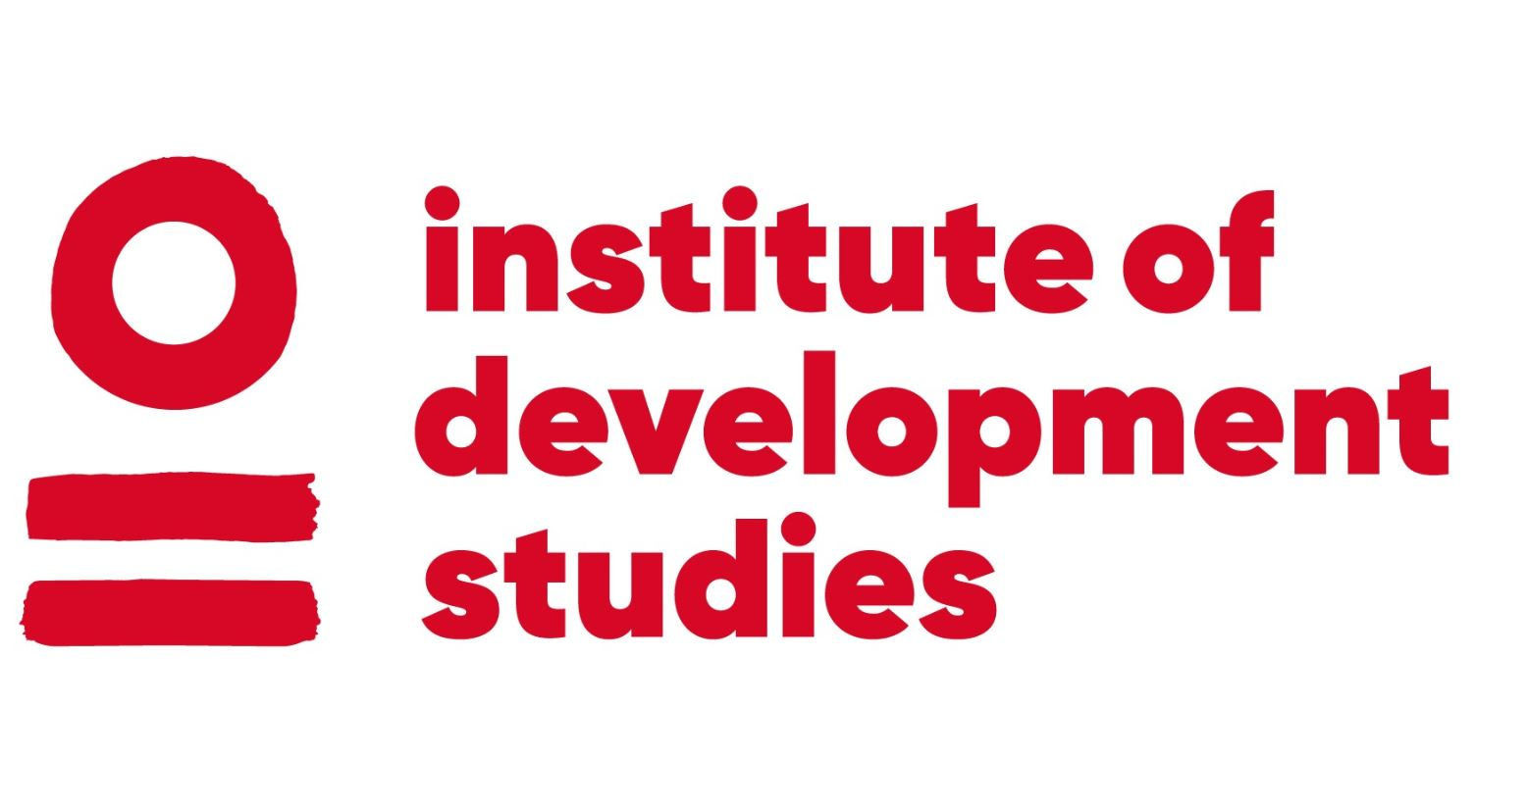 | CURRICULUM VITAE  Lars Otto Naess

Institute of Development Studies E: l.naess@ids.ac.uk
Library Road T: +44 (0)1273 915849
Brighton W: www.ids.ac.uk
BN1 9RE
UK

CURRENT EMPLOYMENT: Research Fellow and Cluster Leader, Institute of Development Studies
THEMATIC EXPERTISE: Climate Change, Agriculture
GEOGRAPHICAL EXPERTISE: Kenya, Tanzania, India and Nepal
OVERVIEW
Social scientist with 25 years’ experience in climate change and development. His research centres on the social and institutional dimensions of adaptation to climate change in a multi-risk context. Focus areas include the useability of climate information and seasonal forecasting by farmers and fisherfolk, understandings of uncertainty across scales of governance, political economy of climate change in rural and urban contexts, and the role of local knowledge for adaptation to climate change. His work has a strong focus on social differentiation of climate change, including justice and equity. The main geographical foci are Sub-Saharan Africa (in particular Kenya and Tanzania) and South Asia (in particular India and Nepal).
EDUCATION AND QUALIFICATIONS
2004 - 2008 PhD, Local Knowledge, Institutions and Climate Adaptation in Tanzania
Tyndall Centre for Climate Change Research, School of Environmental Sciences, University of East Anglia, United Kingdom
1989 - 1994 Cand. agric. (MSc equivalent), Nature Conservation and Resource Economics
Agricultural University of Norway (now Norwegian University of Life Sciences), Norway

RECORD OF EMPLOYMENT
2008 – PRESENT Research Fellow, Institute of Development Studies, UK
Co-convenor, MSc Climate Change, Development and Policy (2016-present). Team leader, Climate Change Team (Oct 2012 - Sep 2013), IDS convenor for MSc Climate Change and Development (2011-2016), Co-convenor, IDS MA Development studies (2009/10).

2013 – 2015 Associate Professor II (20%), Norwegian University of Life Sciences, Ås, Norway
Department of International Environment and Development Studies (Noragric).

2002 – 2008 Research Fellow, Center for International Climate and Environmental Research (CICERO), University of Oslo, Norway

1999 – 2002 Associate Professional Officer, UN Food and Agriculture Organization (FAO), Rome and Tanzania Country Office
Technical advice and project management, LinKS project (Gender, Biodiversity and Local Knowledge Systems to Strengthen Agriculture and Rural Development)
1995 – 1998 Research Assistant, Center for International Climate and Environmental Research (CICERO), University of Oslo, Norway

SELECTED EXPERIENCE
2019 – PRESENT Co-I, ‘Urban Disaster Risk Hub’, Institute of Development Studies, UK

2018- PRESENT Co-I, ‘TAPESTRY’ project, Institute of Development Studies, UK
Transformation as Praxis: Exploring Socially Just and Transdisciplinary Pathways to Sustainability in Marginal Environments, funded by the Norface/Belmont Forum.

2018 – PRESENT Domain editor, Climate and Development, WIREs Climate Change, UK
2017 – PRESENT Associate editor, Frontiers in Sustainable Food Systems, UK
2017 – 2019 Co-I, ‘Sussex Sustainability Research Programme’, Institute of Development Studies, UK
Addressing synergies and trade-offs between goals for climate-resilient agricultural systems in Sub-Saharan Africa.

2016 – 2017 Co-I, ‘Building Resilience and Inclusion in Sub-Saharan Africa through Social Learning around Climate Risks’ project, Institute of Development Studies, UK
Funded by RCUK GCRF.

2015 – 2018 Co-I, ‘Climate Change, Uncertainty and Transformation’ project, Institute of Development Studies, UK
Funded by the Research Council of Norway.

2013 – 2014 Co-PI and Co-Manager, ‘Climate and Development Knowledge Network’, Ghana, Kenya and Mozambique

2012 – 2017 Co-I, ‘Courting Catastrophe? Humanitarian Policy and Practice in a Changing Climate’ Project, Institute of Development Studies, UK
Funded by the Research Council of Norway.

SELECTED PUBLICATIONS AND OUTPUTS
Fazey, I. et al. (2020) ‘Transforming Knowledge Systems for Life on Earth: Visions of Future Systems and How to get There’, Energy Research & Social Science 70: 101724
Nightingale, A.J. et al. (2019) ‘Beyond Technical Fixes: Climate Solutions and the Great Derangement’, Climate and Development: 343-352, DOI: 10.1080/17565529.2019.1624495 (accessed 16 March 2021)
Naess, L.O. and Twena, M. (2019) ‘Local Adaptation Governance: Examining Power Relations’, in E.C.H. Keskitalo and B. L. Preston (eds), Research Handbook on Climate Change Adaptation Policy, Cheltenham: Edvard Elgar Publishing
Naess, L.O. (2018) ‘The Politics of Adaptation to Climate Change: Entry Points for Research and Practice’, in B. Engels and K. Dietz (eds), Climate Change in Africa: Social and Political Impacts, Conflicts and Strategies, Bern: Peter Lang Verlag
Karlsson, L.; Naess, L.O.; Nightingale, A. and Thompson, J. (2018) ‘‘Triple Wins’ or ‘Triple Faults’? Analysing the Equity Implications of Policy Discourses on Climate-Smart Agriculture’, Journal of Peasant Studies 45.1: 150-174
Naess, L.O. (2017) ‘I will Continue to Fight them: Local Knowledge, Everyday Resistance and Adaptation to Climate Change in semi-arid Tanzania’, in P. Sillitoe (ed), Indigenous Knowledge: Enhancing its Contribution to Natural Resources management, Wallingford: CABI Books
Eriksen, S.; Naess, L.O.; Haug, R.; Lenaerts, L. and Bhonagiri, A. (2017) ‘Courting Catastrophe? Can Humanitarian Actions Contribute to Deliberate Transformation in the face of Climate Change?’, IDS Bulletin 48.4: 1-15, DOI: 10.19088/1968-2017.149
Marin, A. and Naess, L.O. (2017) ‘Climate Change Adaptation through Humanitarian Aid? Promises, Perils and Potentials of the ‘New Humanitarianism’, IDS Bulletin 48.4: 15-30, DOI: 10.19088/1968-2017.150
Mosberg, M.; Nyukuri, E. and Naess, L.O. (2017) ‘The Power of ‘Know-Who: Adaptation to Climate Change in a Changing Humanitarian Landscape in Isiolo, Kenya’, IDS Bulletin 48.4: 79-92, DOI: 10.19088/1968-2017.154
Quan, J.; Naess, L.O.; Newsham, A.; Sitoe, A. and Fernandez, M.C. (2017) ‘The Political Economy of REDD + in Mozambique: Implications for Climate Compatible Development’, in F. Nunan (ed), Making Climate Compatible Development Happen, London: Routledge
Naess, L.O.; Newell, P.; Newsham, A.; Phillips, J.; Quan, J. and Tanner, T. (2015) ‘Climate Policy Meets National Development Contexts: Insights from Kenya and Mozambique’, Global Environmental Change 35: 534-544
Naess, L.O. (2014) ‘Climate Change and Agriculture: Lessons from Political Economy Perspectives’, Agriculture for Development 22: 19-22
Quan, J.; Naess, L.O.; Newsham, A.; Sitoe, A. and Fernandez, M.C. (2014) Carbon Forestry and Climate Compatible Development in Mozambique: A Political Economy Analysis, IDS Working Paper 448, Brighton: Institute of Development Studies (accessed 16 March 16 2021)
Okali, C. and Naess, L.O. (2013) Making Sense of Gender, Climate Change and Agriculture in sub-Saharan Africa: Creating Gender-Responsive Climate Adaptation Policy, Future Agricultures Consortium Working Paper 57,, Brighton: Institute of Development Studies (accessed 16 March 2021)
Naess, L.O. (2013) ‘The Role of Local Knowledge in Adaptation to Climate Change’, WIREs Climate Change 4: 99-106

